# ST PAUL’S CATHOLIC PRIMARY SCHOOL

CY331

**TURNER LANE, HYDE, SK14 4AG**

**Tel: 0161 368 2934**

Head Teacher: Miss M Flynn

ST PAUL’S SCHOOL FUND

Dear Parents & Friends,

Some of you will already know that this School has a School Fund but there may be some confusion between this and the “***Diocesan School Buildings Fund***”. This leaflet aims to explain the difference between these Funds, and explains how you can help.

**VOLUNTARY AIDED SCHOOLS**

In this country the majority of schools are “State” schools run and paid for by Local Education Authorities (LEAs) and central government.

But, in addition to these State schools there are a huge number of “Denominational” schools, in other words schools run by churches, for example Church of England schools and Catholic schools, and most (including St Paul’s) are “***Voluntary Aided***” schools.

When the Catholic Hierarchy was restored, 150 years ago, the first directive to the Priests was *“to build Schools”.* The emphasis was on Schools rather than Churches as the first priority. A Catholic education has always been highly valued and this is evident by the number of children in our Schools from non-practicing families and even some non-Catholic families. This importance attached to our Schools and their Christian ethos has continued down to the present day.

However, for the right to promote such Christian values there is “a price” to be paid; the Government insists that the Church is willing to make a financial contribution to the costs of running our schools. Many of these costs, particularly the “buildings” costs initially have to be fully paid for by the Church, but we can then claim back a percentage from the LEA - usually around 90% of the cost. This is what is meant by a school being “***Voluntary Aided***” – we voluntarily agree to meet some of these costs.

**This is why there is :- THE DIOCESAN SCHOOL BUILDINGS FUND**

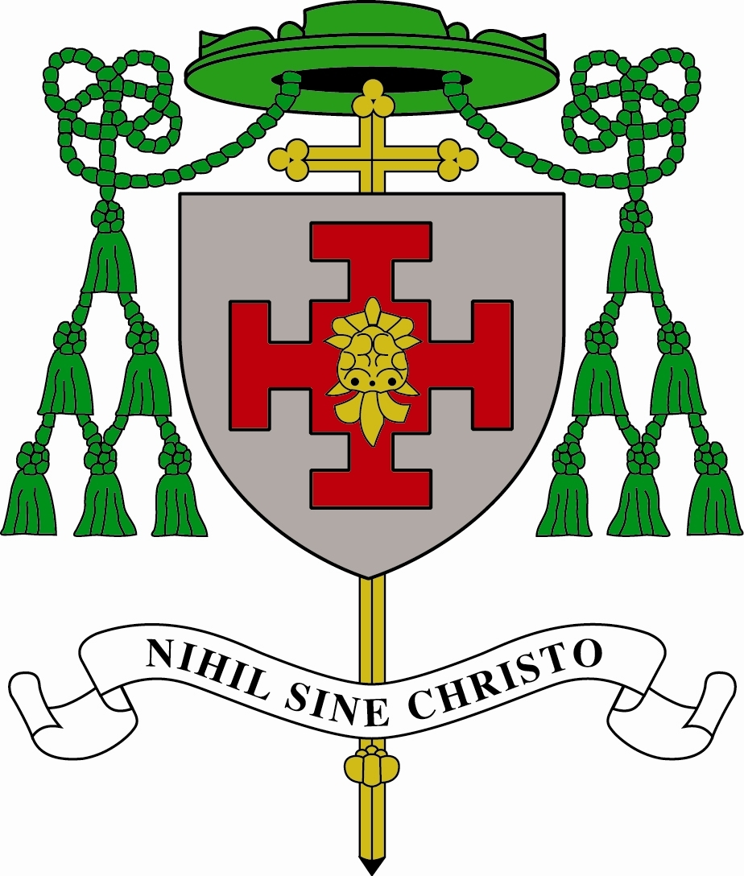

Shrewsbury Diocese, like all Dioceses, is committed to

Catholic Education. Principally this commitment is reflected

in the considerable investment made by the Diocese in our

schools. There are in Shrewsbury Diocese some 110

Voluntary Aided Schools, educating around 40,000 children

and many are oversubscribed. Many of these were built in

the 1950s and 1960s so there is now an essential continuing

schedule of repairs and maintenance being carried out.

As well as repairs and maintenance, improvement works have continued at a substantial rate in recent years. All of our Schools have benefited in some way with facilities in our schools continually being improved: new Classrooms, Libraries, Computer Rooms, etc…

Improvements like these involve a considerable expense. Each year the contribution we in the Diocese have to make as a result of our Voluntary Aided status amounts to around £¾ Million.

Until recently the contribution made by the Diocese came from parishes - through the money given by parishioners at the Offertory collection during Mass. But, as the number of people attending Mass on a regular basis has continued to decrease, the funding of our schools has become increasingly difficult. Because of this the Diocese has set up the ***Diocesan School Buildings Fund.***

CY335

All parents with children in our schools to make an annual

contribution of £15 p.a. All parents are asked to make a

contribution, and you will receive more information about this

in the Autumn term.

**_____________________________________________________________________________________**

**ST PAUL’S SCHOOL FUND**

Each year Schools receive a Budget grant to run the school and pay staff salaries. This is where two problems come to light:-

1. firstly, many have some of the lowest funding levels in the UK
2. secondly, many are considered as being in an “affluent” area and therefore come very low in some LEAs considerations when it looks at the social needs of each school’s area

242

For these two reasons School Budgets simply do not meet schools’ outgoings and many Schools run at a deficit. School Funds are therefore used to enable them to top up their budget grant - School Funds are an absolute essential to provide what the budgets can’t. So, more importantly School Funds are there to help provide for your children those things that excellent teaching staff consider to be absolutely essential to their education, which could not otherwise be provided from current levels of school income. Our schools receive good OFSTED reports and it is essential that they preserve the high quality of our teaching in the school.

**WHY SHOULD YOU BE ASKED TO CONTRIBUTE TO THESE TWO FUNDS?**

**IS THIS NOT WHAT YOU PAY YOUR TAXES FOR?**

Yes, we do pay our taxes and this includes paying for education. But, quite simply, on the school budgets alone the schools are unable to provide for your children the facilities that it is felt your children deserve. The best is not good enough; we want to provide the **very best** and to do this we need your assistance. Parents’ Associations through their fund-raising events make a considerable and welcome contribution, but more is needed - hence School Funds.

**1. MAKING A REGULAR DONATION TO YOUR SCHOOL FUND**

**HOW MUCH ARE YOU BEING ASKED TO DONATE TO THE SCHOOL FUND?**

First of all, please note that School Funds are completely voluntary. Similarly, it is appreciated that the amount you may be able to donate will vary considerably from family to family.

All parents and friends are **invited** to make a regular contribution to School Funds. It is suggested that families might wish to give perhaps £60 or £120 each year – around £1 or £2 per week, far less than the cost of a glass of wine or pint of beer!

It would help the administration of these Funds if donations could be made by a Banker's Standing Order. A monthly Standing Order of £5 from each of 50 families would bring in £3,000 (or £10 would bring in £6,000 each year! Please remember, there is no question of anyone being put under any pressure. All contributions are on a voluntary basis.

It is stressed that all children in our Schools are treated equally. Whatever amount you are able to donate, however large or small will not affect in any way whatsoever the way in which your child or children are treated. Also be assured that it is all confidential.

**2. GIFT AID FOR YOUR DONATIONS**

All our Voluntary Aided Catholic Schools are part of the Diocese of Shrewsbury and therefore have Charitable status. This means that it can make use of “tax advantageous giving”. We are therefore asking you to seriously consider making your donations by **Gift Aid**.



**Questions and answers about the Gift Aid scheme:-**

**WHAT IS GIFT AID AND HOW DOES IT WORK?**

Quite simply, it is the way in which the School can get back some of your Income Tax and it only involves filling in a Gift Aid Declaration, the form that you complete confirming that you wish tax to be reclaimed by the School on any donations from your taxed income.

**WHO CAN USE GIFT AID?**

Anyone can use Gift Aid as long as they are paying Income Tax on their wage, salary, pension or savings.

**what will it cost me? WILL IT COST ME ANYTHING MORE?**

If you are paying any Income Tax then Gift Aid will cost you nothing extra!

**WHAT IF I ALREADY USE GIFT AID FOR MY OFFERTORY DONATIONS TO MY PARISH AND/OR THE DIOCESAN SCHOOL BUILDINGS FUND?**

Donations under the Gift Aid scheme to a Parish or the Diocesan School Buildings Fund and/or the School Fund would be entirely separate and would not affect you in the slightest; nor would it involve you in any extra cost or inconvenience.

**WHAT DOES IT INVOLVE?**

All you have to do is to sign the Gift Aid Declaration and make your donations - the School will do the rest.

**IS IT CONFIDENTIAL ?**

**YES!** None of the teaching staff in the School will know whether or not you are donating to the School Fund and/or how much you are donating and/or if you are using Gift Aid for your donations.

**WHAT HAPPENS IF…… ?**

Should you stop paying Income Tax, or if your child leaves the School or if for any reason you wish to stop making your donations - you only have to contact the School and let us know - you do not need to give a reason.

**WHAT WILL THE SCHOOL GAIN ?**

Gift Aid increases the value of your donation by one-quarter. No matter how large or small your donation it is important that you use Gift Aid if you are a Tax Payer.

|  |  |  |
| --- | --- | --- |
| Your annual donations | Gift Aid | Total to School |
| £20 | £5.00 | £25.00 |
| £50 | £12.50 | £62.50 |
| £100 | £25.00 | £125.00 |
| £500 | £125.00 | £625.00 |
| £1,000 | £250.00 | £1,250.00 |

Do be assured that whatever you donate to the School Fund (and any Income Tax recovered by Gift Aid) will come to your individual School to be used for the benefit of your children (**NOT** to the Diocese). We would all agree that we would like to see the Government providing much more funding for Education. The Governors and Staff of our Schools are proud of their School’s achievements and what is done for our children, but we are also very aware of how much more they could do if there were more resources available to them.

We are all part of the family of Shrewsbury Diocese

Family%201