
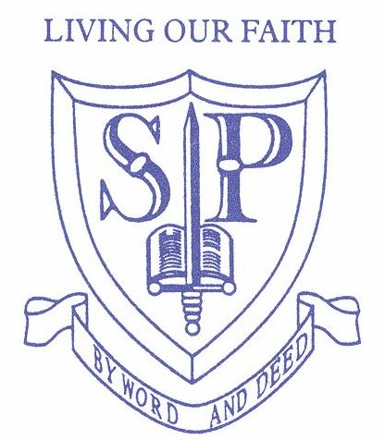

Who are the Friends of St Paul’s …

Friends of St Paul’s is a group open to everyone who knows a child at St Paul’s Primary School and the staff who work there. This includes parents, carers, grandparents, aunties, uncles and friends.

- FOSP meetings are held on a several times during each school term.

- Our main aim is focusing on raising money for the school by planning fun events!

- It is important to note that all of the money raised from events is invested back into the school. Teachers and parents are able to make requests for items and equipment that are needed for the children.

Welcome to all the new parents who have children that have started at the school this year, and those who are continuing their school journey.

We are always looking for volunteers to help out at school events. Your ideas and support are very valuable to us and we rely on volunteers help to make our events successful. If you are interested in joining FOSP you can attend our meetings, all meeting dates are printed in the schools newsletter.

We look forward to seeing you all soon…
Friends of St Paul’s
St. Paul’s Catholic Primary School
The Friends of St Paul’s

