**St Paul’s Catholic Primary School Handwriting Policy**

**Aims**

**For Teachers**

1. To know the correct style, letter formations and joins in handwriting to ensure consistency across the school
2. To ensure high expectations in handwriting lessons and that pupils are expected to apply the same standards in other independent writing
3. To improve the standards of writing across the school and to encourage our pupils to be effective writers who enjoy the writing process

**For Pupils**

1. To know the importance of clear and neat presentation in order to communicate meaning effectively
2. To write legibly write without thinking about **how** to write, enabling them to concentrate on **what** to write.

**Teaching time**

|  |  |
| --- | --- |
| Early Years Foundation Stage | daily practise, short sessions |
| Key Stage 1 | 2 x 15 minute sessions |
| Lower Key Stage 2 | 2 x 15 minute sessions |
| Upper Key Stage 2 | 1 x 15 minute session |

Handwriting can be linked to phonics so that we reinforce the movement of the letter(s) whilst learning the sound. For example when learning digraph or trigraphs, teachers will model these joins and pupils will have the opportunity to practise them too. However, the teaching of Handwriting should occur at other times as well, allowing opportunities to practise accuracy without the distraction of having to compose text or think about spelling.

**Model used**

EYFS used the Read, Write, Inc handwriting model which provides children with a visual picture and a rhyme to support each letter formation (see appendix 1).

St Paul’s Catholic Primary school uses the Nelson Thornes Handwriting Scheme with the following letter and numeral formation:

**Lower case letters**



**Capitals**

**A B C D E F G H I J K L M N O P Q R S T U V W X Y Z**

**Joined**



**Number formation**

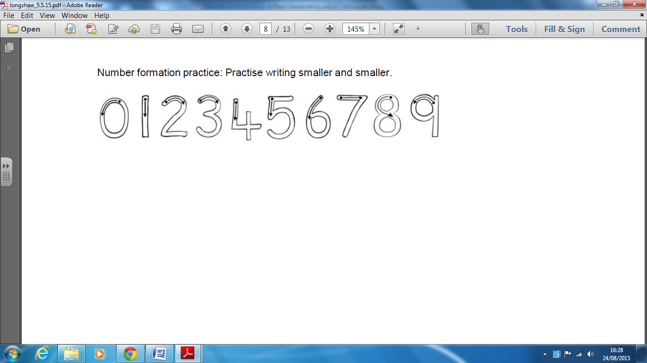

**The break letters** (letters that aren’t joined **from**) are:

b g j p q x y z s

(See appendix 2 for examples of the break letters)

When marking or writing comments, members of staff should use cursive handwriting as appropriate. All members of staff are expected to promote the agreed handwriting style when modelling writing.

**Books**

Most pupils will use lined books for handwriting so that they are learning to write on lines that are the same size as the books they will produce most of their work in.

**Pencils and Pens**

Pupils will use HB pencils initially and move onto handwriting blue ink pens. They may start using pens in handwriting lessons and then begin to use them in all lessons when their writing is neatly joined and a consistent size. Pens must be introduced in handwriting lessons in Year Four at the latest. When pupils start to use pens in their independent writing they will be given a ‘pen license’ and a blue ink pen labelled with their name.

**Seating and posture**

* Chair and table should be at a comfortable height
* The table should support the forearm so that it rests lightly on the surface and is parallel to the floor
* Encourage children to sit up straight and not slouch
* The height of the chair should be such that the thighs are horizontal and feet flat on the floor
* Tables should be free of clutter
* Rooms should be well lit

**Left Handed Children**

* Model letter formation specifically for them
* Sit them to the left of right handed children or on the ends of tables so writing arms don’t clash
* remind them to have their paper to the left of centre and tilted to the right
* pencil grip many be 1.5cm from the end of the pencil so that their line of vision is not impeded

**SEN**

* Children who experience difficulty in developing necessary skills will be supported in small groups or individually, with targets specified on ILPs
* Pencil grips, handwriting apps, tracing activities are available in school
* Interventions such as ‘Motor Skills United’ are used to support children with poor fine motor skills

**Parental involvement**

Parents will be informed of the school’s policy on handwriting at the New Intake meetings and it will available on the school website. Parent help sheets showing the correct formation will be distributed as part of induction.

**Assessment**

Teachers will assess pupils on a termly basis to decide where teaching should begin in the Progression Ladder. The year group starting points are a guide and teachers will need to use their professional judgement. However, be aware of the expectations at the end of the year.

Pupils may need to be grouped into 2 or 3 ability groups based on their handwriting ability (this may be different to their writing level). Work will be differentiated and a teaching assistant may teach and work with one ability group.

Children must be assessed on entry into Year Three to see if they are using the correct letter formation for individual letters first. If they are not starting in the correct place they will not be able to join letters accurately. Pupils who need to learn correct letter formation for some letters must be taught this before they begin to join. Some pupils will have begun to learn and use joined handwriting in Year 2 and will need to start from that position in the Progression Ladder (See Appendix 5 for Progression Ladder).

**Date:** March 2017

**Review Date:** March 2019

**APPENDIX 1 Letter formation rhymes (taken from Read, Write, Inc) for all EYFS/KS1 staff**

a-Around the apple, down the leaf.

b-Down the laces to the heel, round the toe.

c- Curl around the caterpillar.

d- Around his bottom, up his tall neck, down his feet.

e- Lift off the top and scoop out the egg.

f- Down the stem, and draw the leaves.

g- Round her face, down her hair and give her a curl.

h- Down the head to the hooves and over his back.

i-Down the body, dot for the head.

j- Down his body curl and dot.

k- Down the Kangaroo’s body, tail and leg.

l- Down the long leg.

m- Maise, mountain, mountain.

n-Down Nobby, over his net

o- All around the orange.

p- Down the plait and over the pirates face.

q-Round her head, up past her earrings and down her hair.

r- Down his back, then curl over his arm.

s- Slither down the snake.

t- Down the tower, across the tower.

u- Down and under, up to the top and draw the puddle.

v- Down a wing, up a wing.

w-Down up, down up.

x- Down the arm and leg, down the other arm and leg

y-Down a horn up a horn and under his head.

z- Zig-zag-zig

**APPENDIX 2**

**Examples of the break letters**



**APPENDIX 3**

**Examples of the joins**



**APPENDIX 4**

**Letter formation families** –a common handwriting language to be used across the school.

(To be introduced from Year 1)

**Long ladder** (l ) –down and off in another direction i, j, l, t, u

**One-armed robots** (r ) –down and retrace upwards b, h, k, m, n, p, r

**Curly caterpillar** (c ) –c, a, d, g, o, q e, s, (all formed from the letter c except e and s)

**Zig Zag letters** - v, w, x, z

**Ascenders and Descenders** –the bodies (tummies) of the letters sit on the lines and are the same size as the letter x

**Capital Letters** –always stand on the lines and are never joined

**Exceptions** - t is shorter than the other ascenders; f is an ascender and a descender

**APPENDIX 5 - Progression ladder**

**EYFS**

**Nursery** children are taught to:

* Develop their fine and gross motor skills with a range of multi-sensory activities
* Practise patterns and free-flowing hand motions both clockwise and anti clockwise
* Have the correct pencil grip
* Write the capital of their name
* Correctly form the lower case letters following the RWI letter patter
* Write numerals
* Write from left to right and from top to bottom of the page
* Start and finish letters in the correct places (at first using start and stop spots on their names for support)

In addition to reinforcing the above, children in **Reception** are taught to:

* Sit letters on the line, and ensure that ascenders reach the appropriate height, and descenders come below the line
* Consolidate writing the lower case letters following the RWI letter patter
* Have the correct pencil grip
* Find a convenient position for their page
* Have the correct posture and position
* Write upper case letters

**Year 1**

* Sit correctly at a table, holding pencil comfortably and correctly
* Form lower-case letters in the correct direction, starting and finishing in the right places
* Form all capital letters correctly
* Use appropriate spacing between words
* Begin to understand which letters belong to which families (letters that are formed in similar ways and practise them (see appendix 4)

**Year 2**

* Form lower case letters of the correct size relative to one another
* Start using some of the diagonal and horizontal strokes needed to join letters
* Know which letters are ‘break’ letters
* Write capitals and digits of the correct size, orientation and relationship to one another and lower case letters
* Use spacing between words that reflects the size of letters
* Learn to write using a joined style as soon as they can form letters securely

**Year 3 & 4**

* Use the diagonal and horizontal strokes needed to join letters and understand which letters are ‘break’ letters
* Increase legibility, consistency and quality of their handwriting (for example by ensuring that the downstrokes of letters are parallel and equidistant; that lines writing are spaced out sufficiently so that the ascenders and descenders of letters do not touch)
* Use joined writing throughout their independent writing
* Continue to increase fluency

**Year 5 & 6**

Write legibly, fluently and with increasing speed by:

* Adapting their handwriting for different purposes eg. quick notes or work in books/ for display, labelling diagrams or filling in forms in capitals.
* Once they are secure with the Nelson scheme, develop own style (must remain joined).